Access My Grades
My Grades will show you the scores, rubrics, comments and submission status of your assignments.

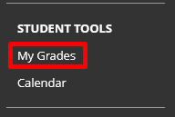
- Go to My Grades.
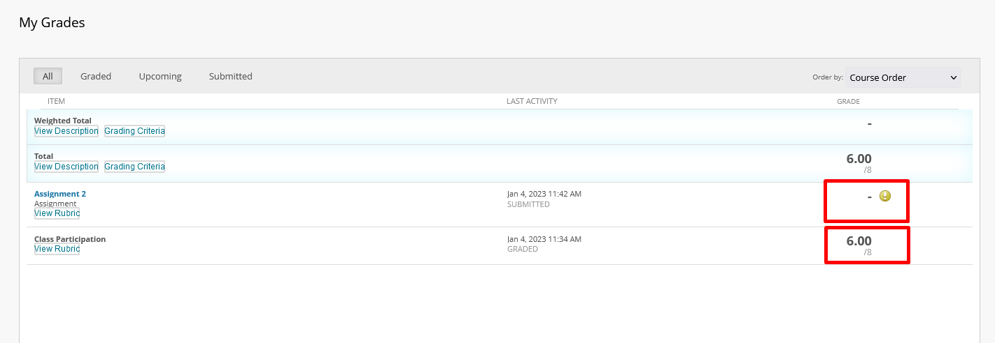
- You can then see if your assignment is graded or submitted and the grade.
Submitted, but not graded
Submitted, and graded
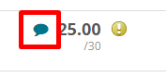
- If the instructor has made comments you will see the comment icon.

Interested in more educational tools? Check out our How-To Guides at: www.ufv.ca/myclass/faculty-centre/faculty-tutorials or email us at asktlc@ufv.ca

