Add a Course Banner
Make sure edit mode is on
(Top right of screen)
Edit Mode is ON | Click to toggle. | Edit Mode is Off
 | 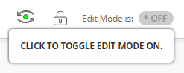
You can add a course banner at the top of your entry page. If you do not have a banner already email a banner request to online@ufv.ca and save the image on your computer.
If you have used a banner for this course before, go to the old course shell Click Content Collection, Click on the Course CRN, find the banner image and download to your computer.

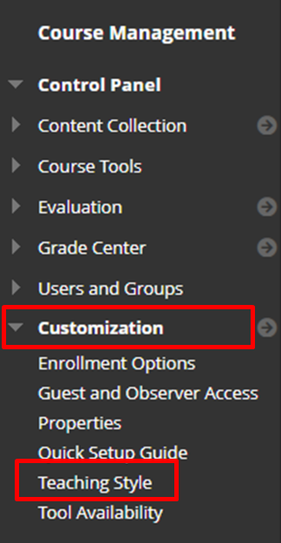
- Go to Customization then Teaching Style

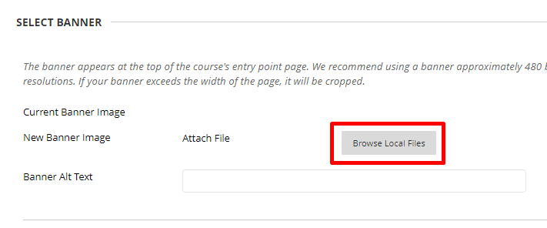
- Scroll down to Select Banner and click Browse Local Files
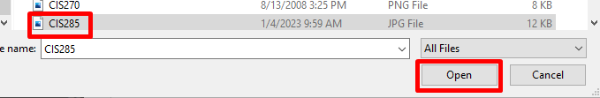
- Find and select the banner image on your computer.
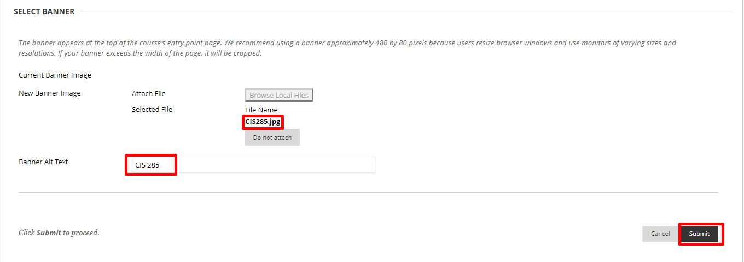
- Check if the Selected file is correct and click Submit.

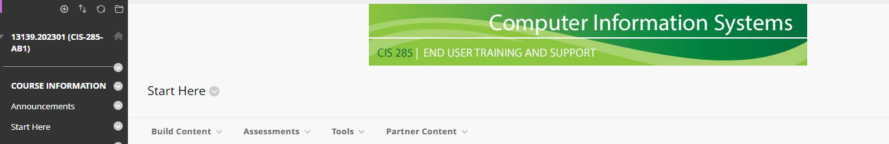
- The banner will now be on your course entry page.

Interested in more educational tools? Check out our How-To Guides at: www.ufv.ca/myclass/faculty-centre/faculty-tutorials or email us at asktlc@ufv.ca

