Course Copy
Make sure edit mode is on
(Top right of screen)
Edit Mode is ON | Click to toggle. | Edit Mode is Off
 | 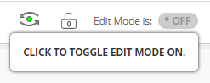 | 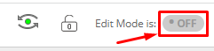
You can copy a course from a previous semester to a newer semester by using this function. You can copy over as much or as little of the course as you would like.

- Go to the old course.
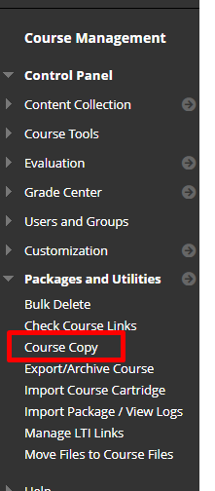
- Click Course Copy under Packages and Utilities.

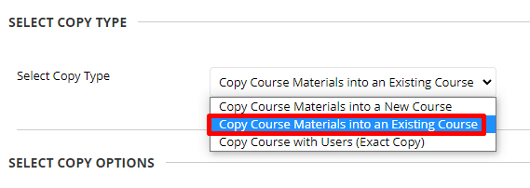
- Select copy type. In most cases you will choose to copy Course Materials into an Existing Course

- Click browse and search for your course.

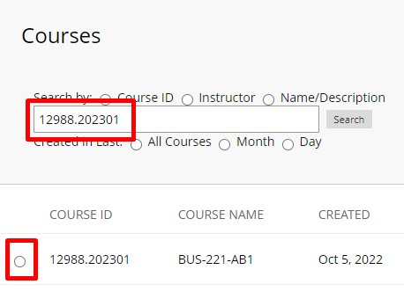

- Select all the content or choose the individual pages you would like to copy over.
- Make sure to deselect Announcements as the past dated announcements would copy over.
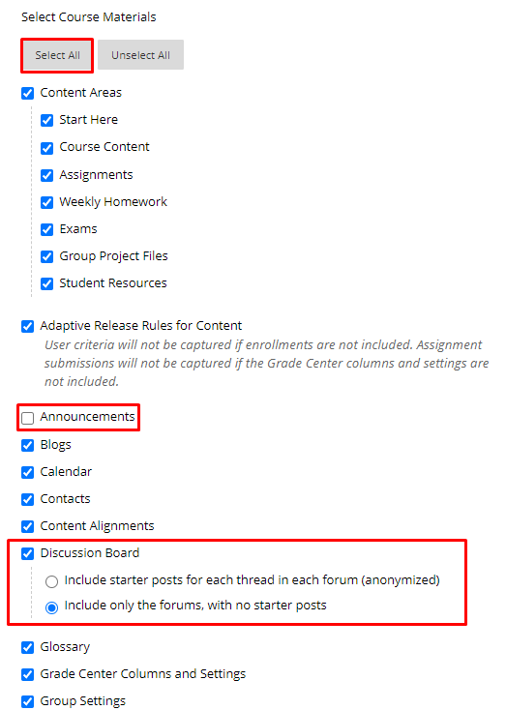
- For discussion posts choose to only include only the forums, or you will have old discussion posts from previous students.
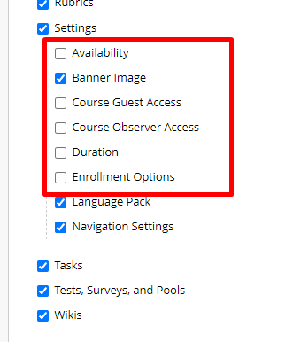
- Deselect all Settings other than Banner Image, Language Pack and Navigation Settings

- You will be notified when the course copy is done by email. If you have a lot of files in your class, it will take a few minutes.
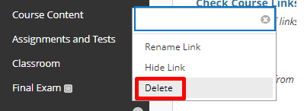
- Once you receive the email go to your new course and delete any unused or duplicate menu items. Leaving unused menu items will cause confusion in your structure.

Interested in more educational tools? Check out our How-To Guides at: www.ufv.ca/myclass/faculty-centre/faculty-tutorials or email us at asktlc@ufv.ca

