How to Create a Test
Make sure edit mode is on
(Top right of screen)
Edit Mode is ON | Click to toggle. | Edit Mode is Off
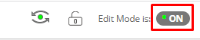 | 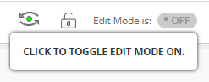 | 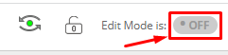
You can create tests, surveys and pools that will allow you to post questions to your students.

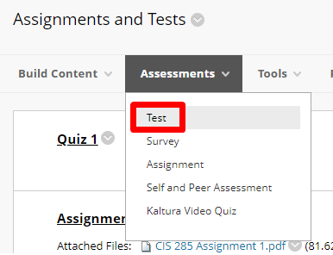
- Go to the content area you would like to create the test in and choose Assessments Tests.

- Click Create a New Test

- Type the test name and add a description and instructions if you wish.
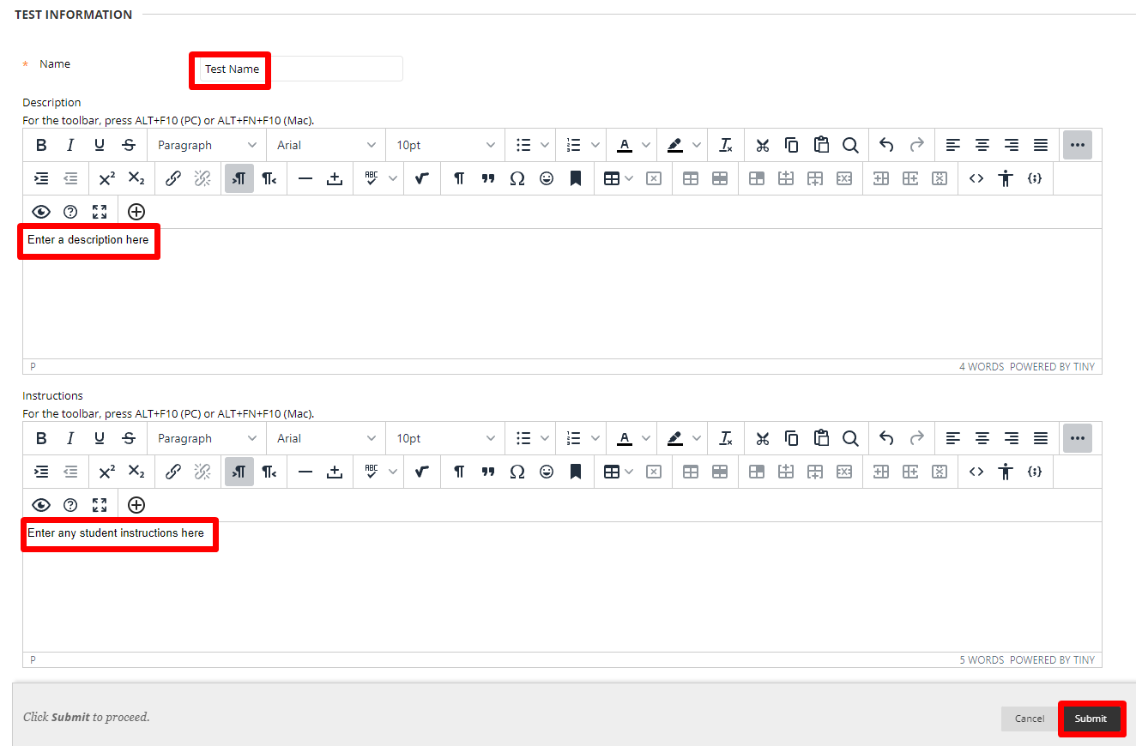

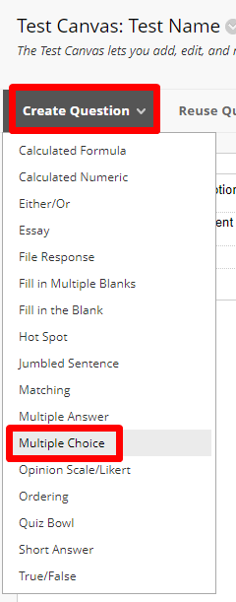
- Click Create Question and choose the type of question you would like to create.
- Create the question.

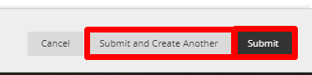
- Choose Submit or Submit and Create another.

- Edit the number of points for each question.
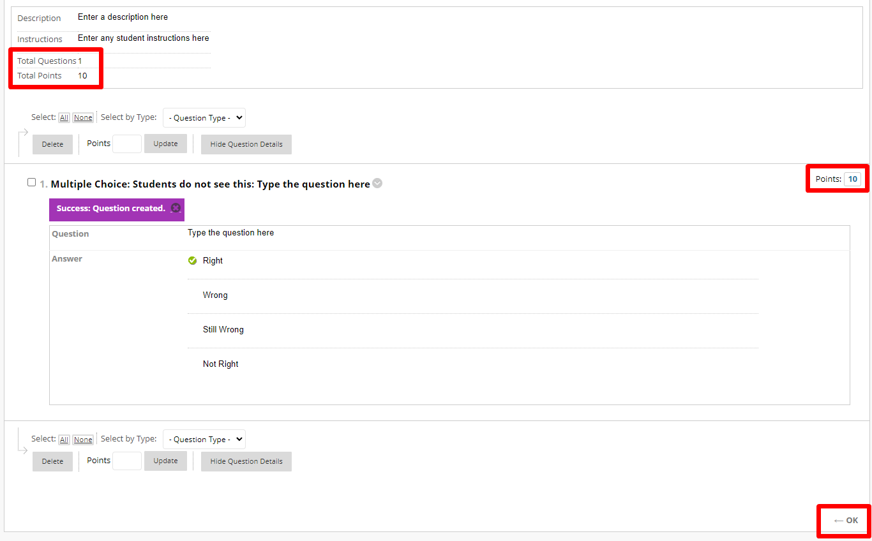

- Keep creating questions as needed. And Press OK.
- Select the current test and click submit

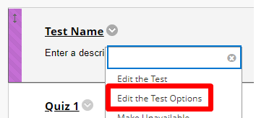
- Edit the test options
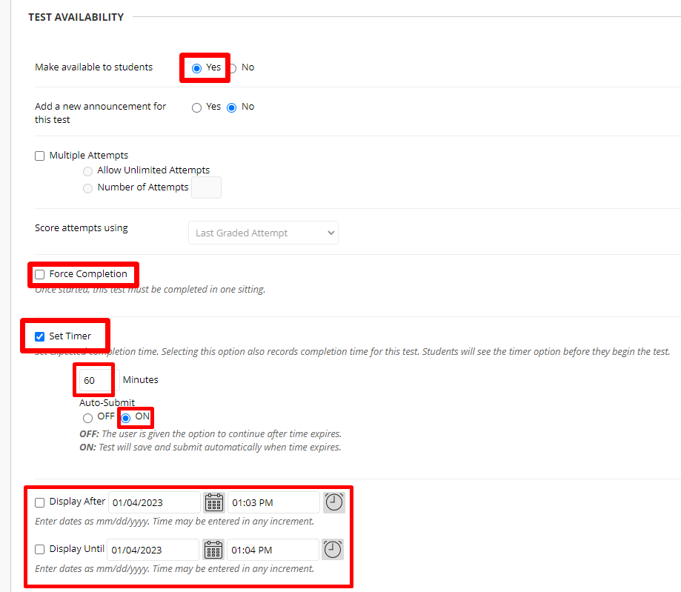
- Ensure Test is available. Do not select Force Completion. Set the timer if required and set the display after and until dates. NOTE: Selecting a Display Until date will remove the test from the students grades. Instead set a due date and do not allow students to start after the due date.
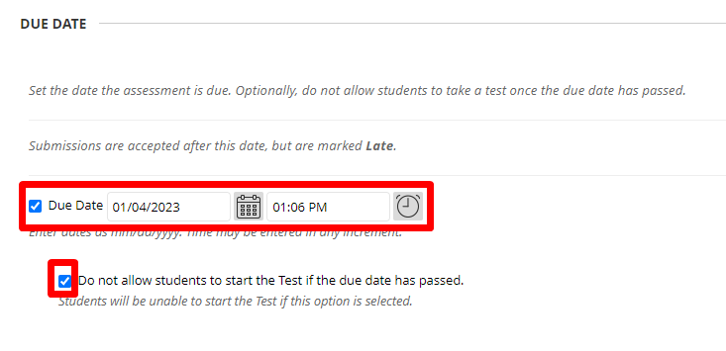
- Set due date and set that students cannot start the test after the due date.
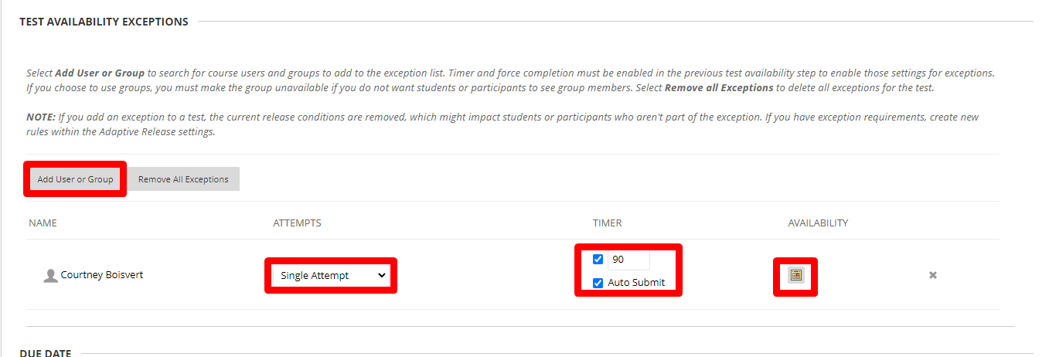
- Set exceptions if required. This is optional and can be used if a student needs extra time or needs to be able to write on a different date.
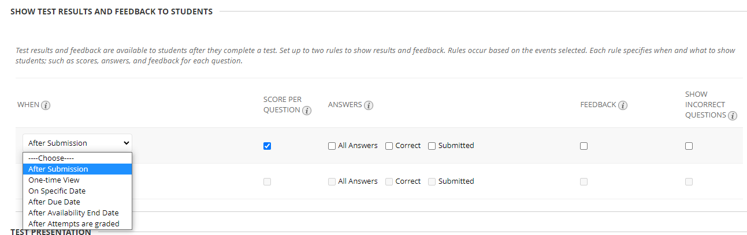
- Choose when and how to provide students feedback if desired.

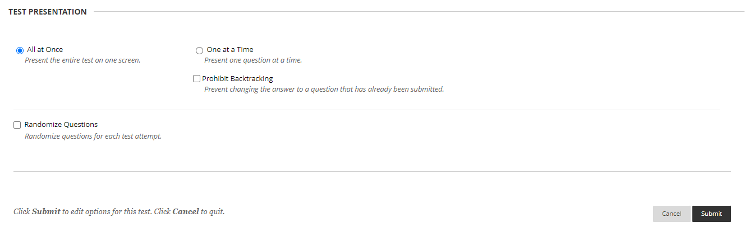
- The default is for all the questions to be asked at once. You can change this to one at a time and decide if students may backtrack. You can also randomize the questions.

Interested in more educational tools? Check out our How-To Guides at: www.ufv.ca/myclass/faculty-centre/faculty-tutorials or email us at asktlc@ufv.ca

