How to Create and Edit an Assignment
You can create and edit an assignment for your students to submit into a dropbox.

Make sure edit mode is on
(Top right of screen)
Edit Mode is ON | Click to toggle. | Edit Mode is Off
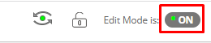 | 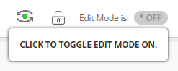 | 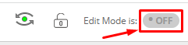
- Click on a content area.
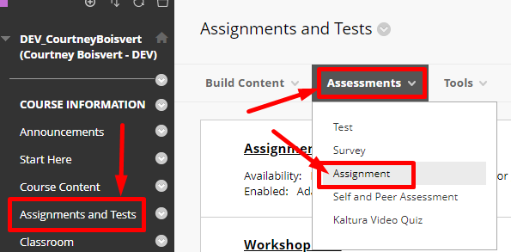
- Click on Assessments Assignment.

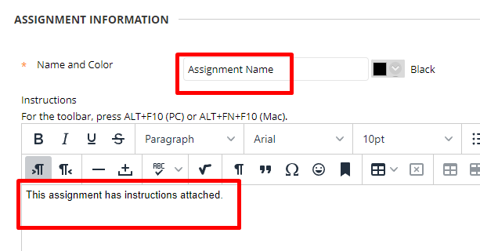
- Provide the name, choose a colour if you wish to have it a colour other than black. And enter in the instructions for the assignment.

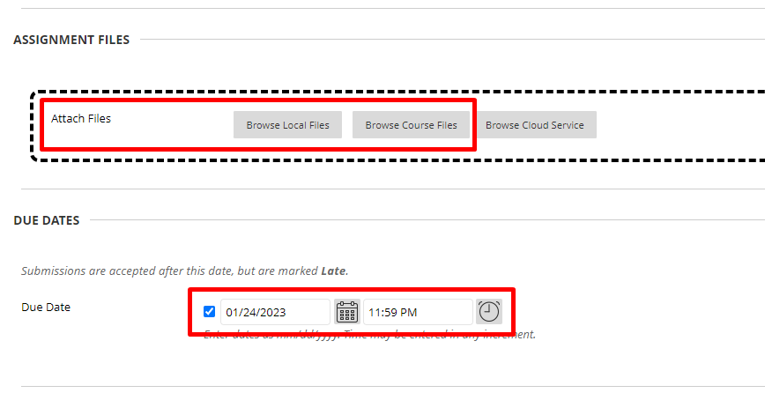
- You can attach an instruction file if you have one or any other files the students may need to complete the assignment. You can also set the due date. Remember Midnight is 12AM and End Of Day is 11:59PM.
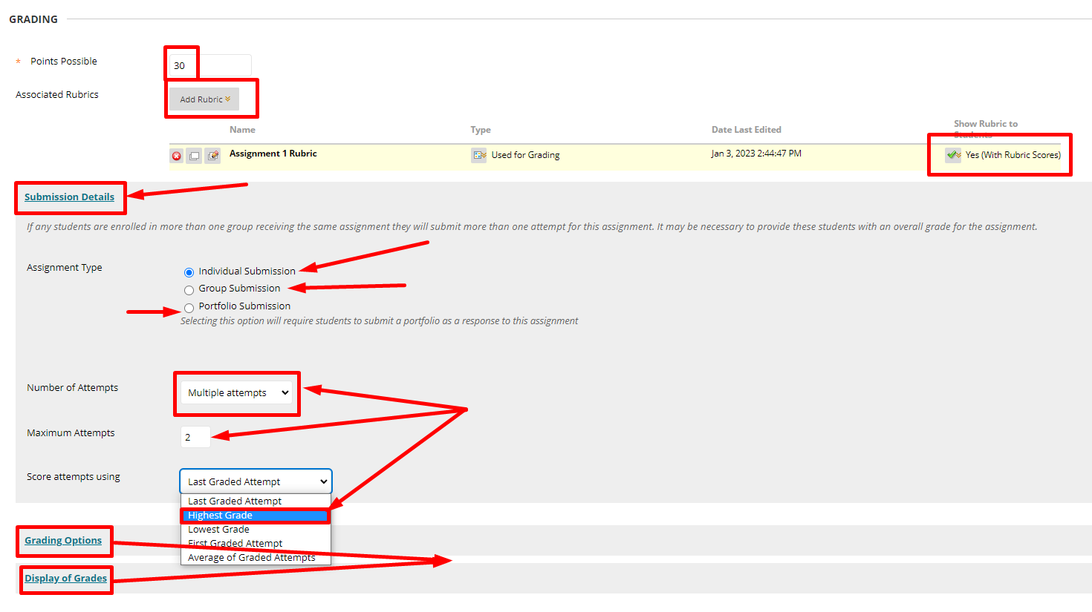
- Points possible does not need to be out of 100. It can be weighed in weighted total later. You can add a rubric to mark students, but it is recommended that you show the Rubric with Rubric scores to the students. Submission details will let you change from Individual Group or Portfolio. In order to use Groups you must have groups created. Portfolio submission is only for portfolios. A single attempt is fine, however you will have to clear submissions if students make a mistake uploading. 2 Multiple Attempts is sufficient in case students have uploading problems.
Default
- Check the box for Make the Assignment Available.

- Feel free to choose the Display After date, but do not use Display Until as that means that the students cannot see their grade for the assignment in the Grade Centre. Press Submit.
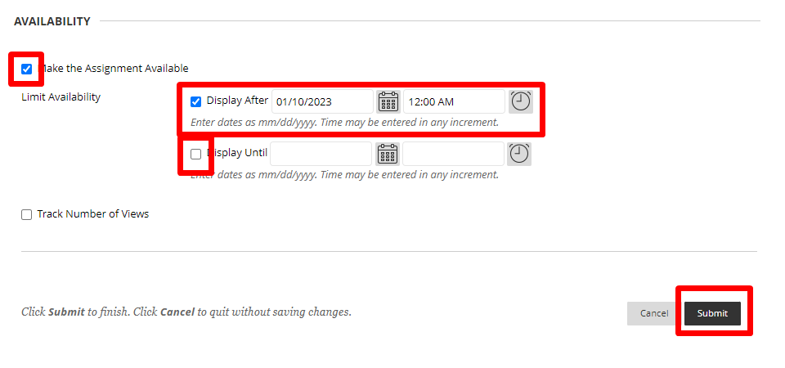
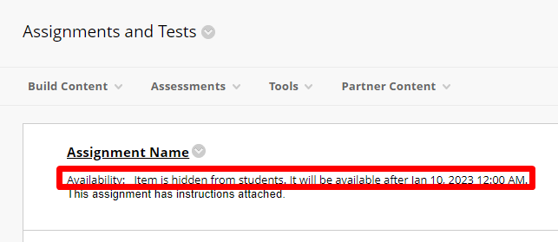
- You can tell the assignment is not available yet as it will say: “Availability: Item is hidden from students. It will be available after [Date you chose].”

- To edit the assignment, click on the down arrow next
to Assignment Name and choose edit.
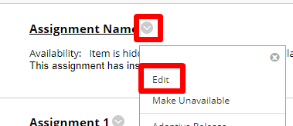

Interested in more educational tools? Check out our How-To Guides at: www.ufv.ca/myclass/faculty-centre/faculty-tutorials or email us at asktlc@ufv.ca

