Edit an In-Progress Test
Make sure edit mode is on
(Top right of screen)
Edit Mode is ON | Click to toggle. | Edit Mode is Off
 | 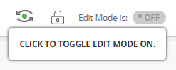
If a student begins a test but doesn’t submit it you cannot grade it. This process shows you how to submit the test for you to grade it.

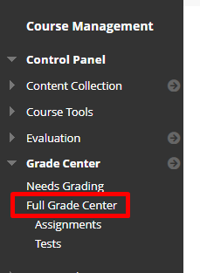
- On the left hand menu click grade center then full grade center.
- A test is in progress if you see a small pie chart in the place where the grade should be in the grade center.
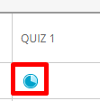

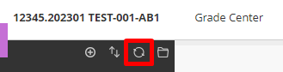
- First press refresh at the top of the left hand menu to ensure that the student hasn’t submitted while you were in the grade center.
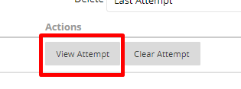
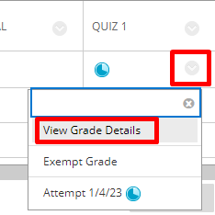
- If the test is still in progress press the arrow next to the in progress icon and choose view grade details.
- Choose view attempt.
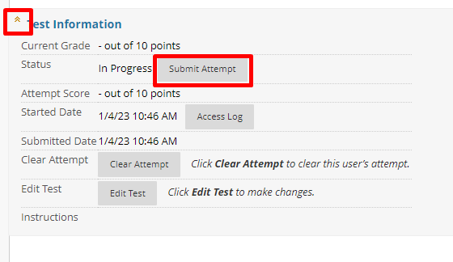
- Expand Test Information and press Submit Attempt

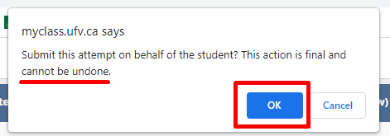
- Confirm that you want to submit the attempt as this cannot be undone.
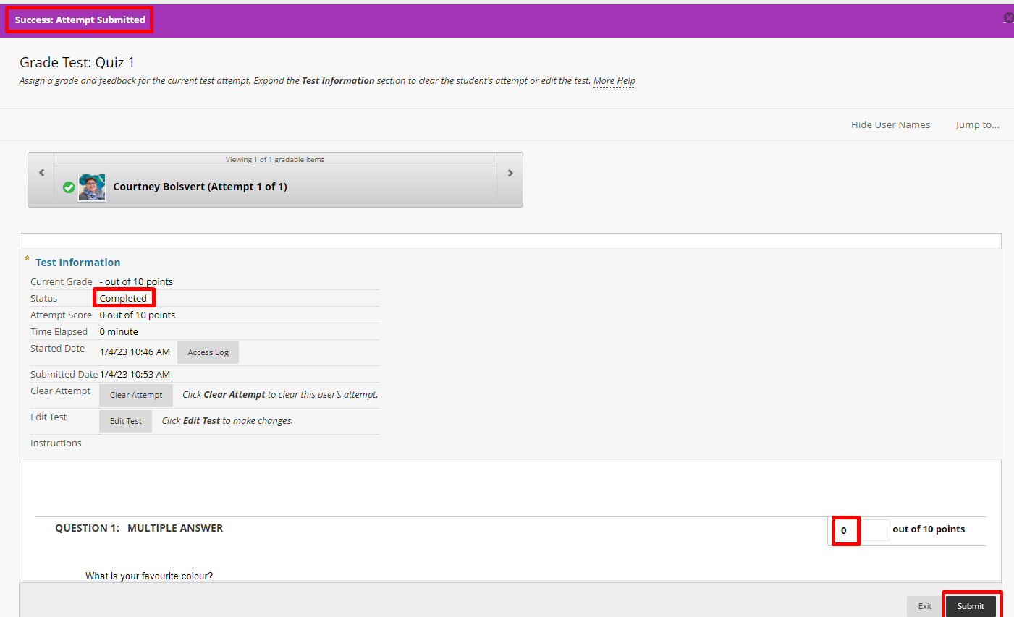
- The test information will now say completed. You can press submit.

Interested in more educational tools? Check out our How-To Guides at: www.ufv.ca/myclass/faculty-centre/faculty-tutorials or email us at asktlc@ufv.ca

