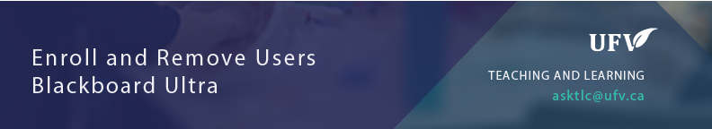

Enroll and Remove Users
Make sure edit mode is on
(Top right of screen)
Edit Mode is ON | Click to toggle. | Edit Mode is Off
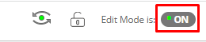 | 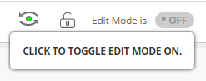 | 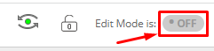
This allows you to choose for an assignment to be released to only a specific student during a specific time. An example for this use is in the case of a CAS accommodation.

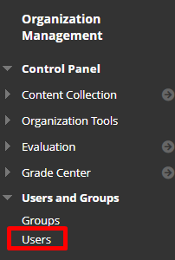
- Under Users and Groups Click Users

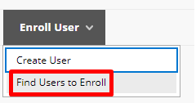
- Click Enroll User Find Users to Enroll.
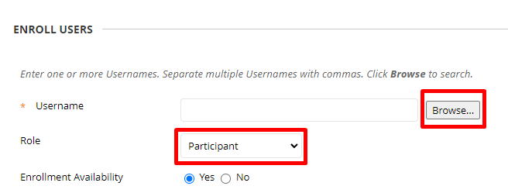
- Set the Role of the User and Click Browse
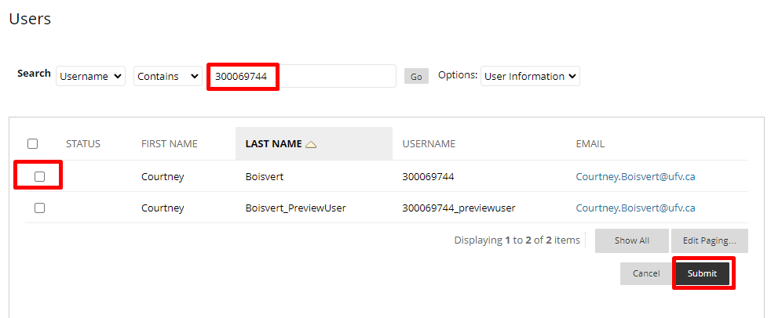
- Search for and select the user you wish to enroll.
- Click Submit.

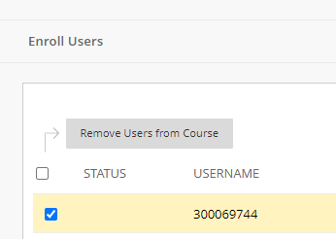
- Check the box of the students you wish to remove from the course and click Remove Users from Course.

Interested in more educational tools? Check out our How-To Guides at: www.ufv.ca/myclass/faculty-centre/faculty-tutorials or email us at asktlc@ufv.ca
