Student Preview Mode
Make sure edit mode is on
(Top right of screen)
Edit Mode is ON | Click to toggle. | Edit Mode is Off
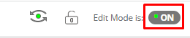 | 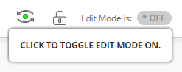 | 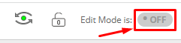
To see your course as a student sees it you need to enter Student Preview Mode. When doing this you will create files and be prompted whether to save those for future.

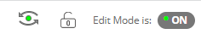
- In the top right you have a green circle with arrows above and below looking like an eye.
- When the student preview is on there will be an orange bar at the top that says Settings or Exit Preview

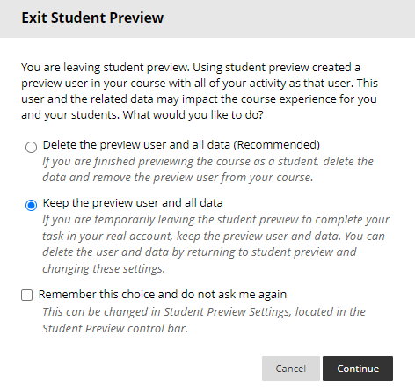
- When exiting Student Preview you can choose to keep the preview user data or delete the user data.

Interested in more educational tools? Check out our How-To Guides at: www.ufv.ca/myclass/faculty-centre/faculty-tutorials or email us at asktlc@ufv.ca

