Zoom - How to Make Group Meeting Rooms

Email: askTLC@ufv.ca Video: video.ufv.ca

1] (myClass course’s left menu) Zoom Classroom

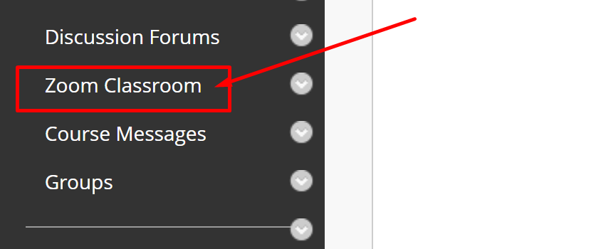

2] (top right) Schedule a New Meeting

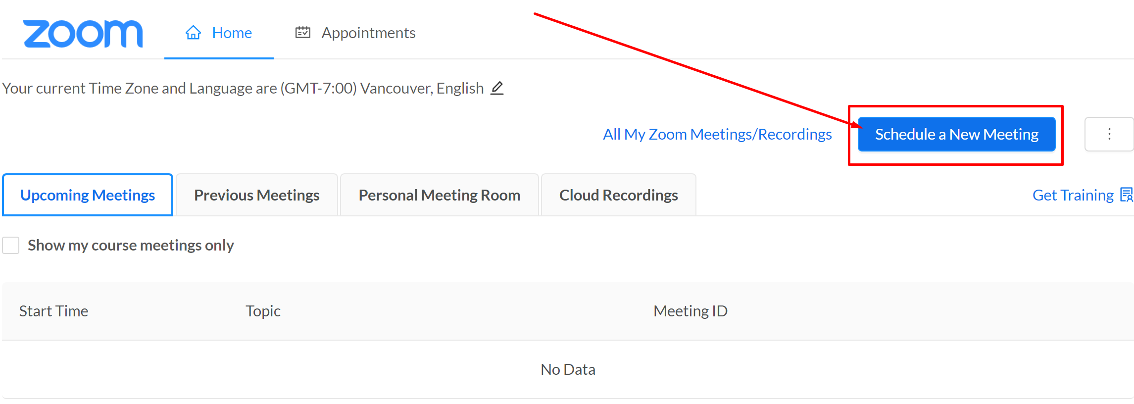

3] Group Name > Recurring Meeting > No Fixed Time

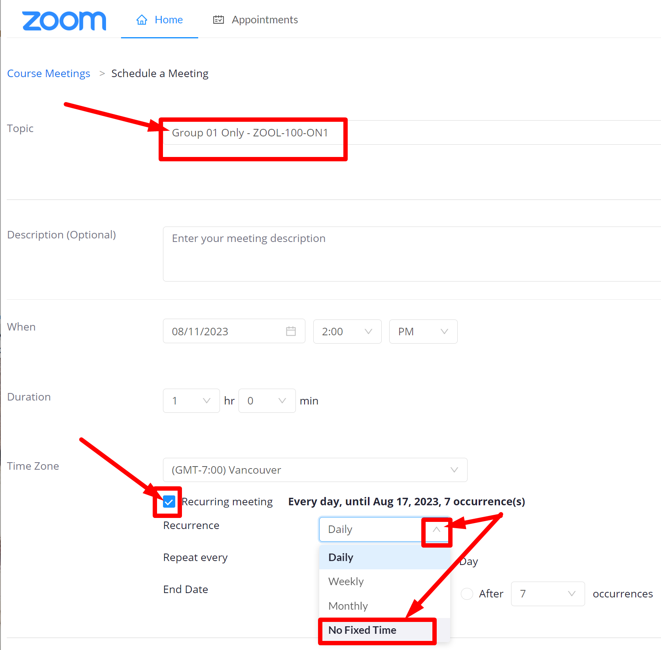

4] (below) Enable join before host
> Mute participants upon entry
> One or more student email addresses from the group
> Save

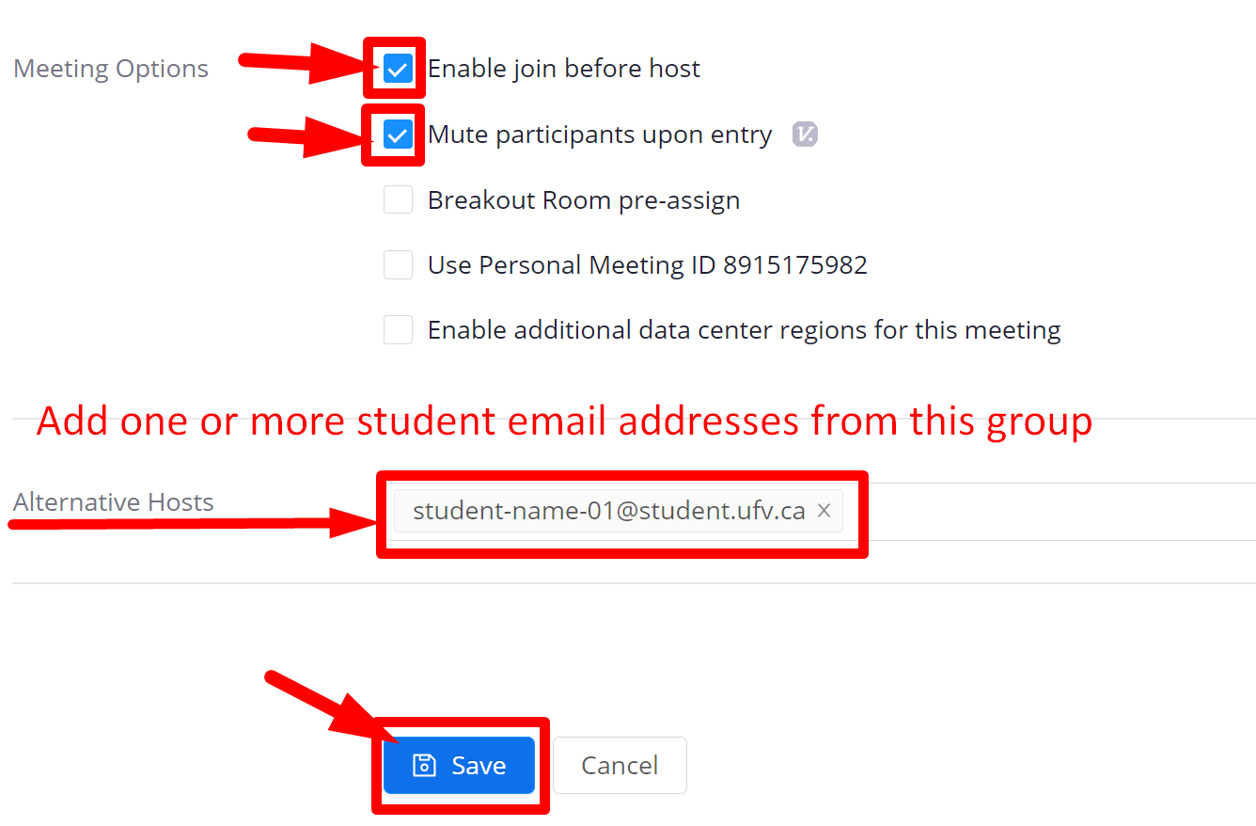

5] Go back to the Zoom Classroom page and create more group Zoom rooms.

Revised by Soowook Kim on AUG 11, 2023.

