Change Course Name
Make sure edit mode is on
(Top right of screen)
Edit Mode is ON | Click to toggle. | Edit Mode is Off
 | 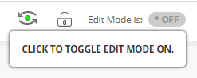 | 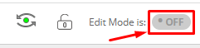
You can change the name of your course so that it makes more sense to the students. The course ID is assigned by Banner and can not be changed.

- In course management click customization and then properties.
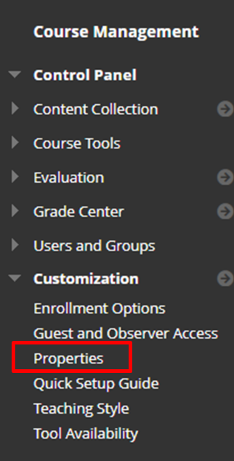

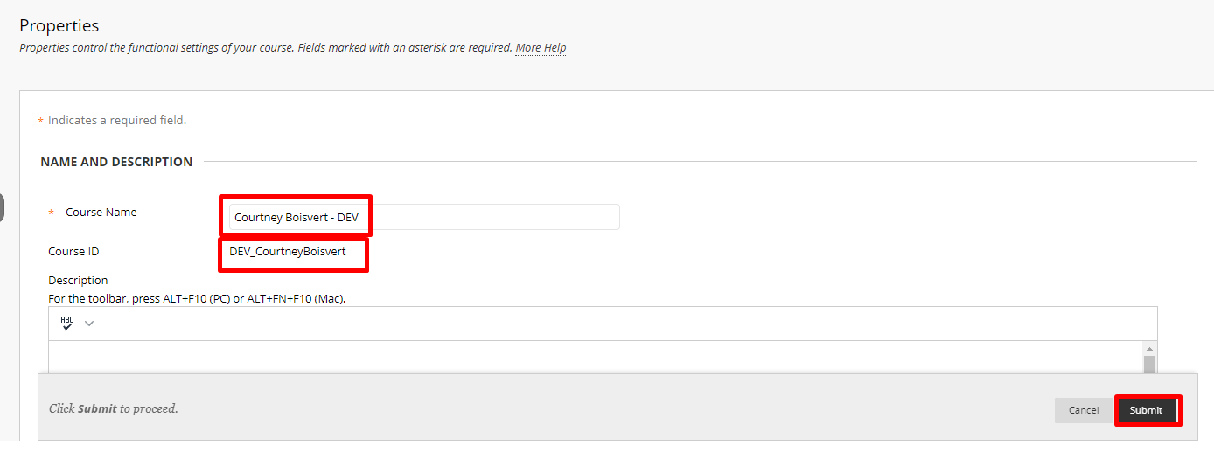
- Change the name to something descriptive.

Interested in more educational tools? Check out our How-To Guides at: www.ufv.ca/myclass/faculty-centre/faculty-tutorials or email us at asktlc@ufv.ca

