Create a Tool Link
Make sure edit mode is on
(Top right of screen)
Edit Mode is ON | Click to toggle. | Edit Mode is Off
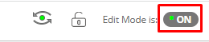 | 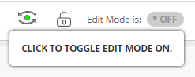 | 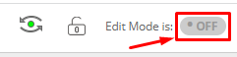
There are some default tool links on the left side menu, but you may want to add more. You can add any tool to the left side menu.

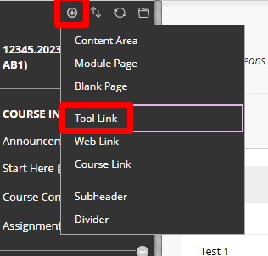
- Click the Plus (+) above the menu

- Name the tool and choose what type of link it is.
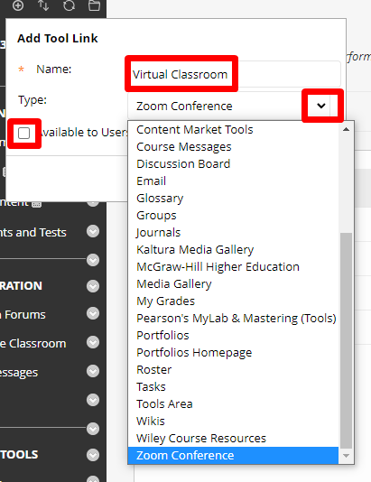
- Make sure its available to users and click submit.
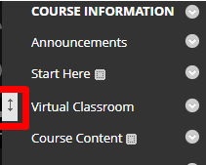
- The new tool link will appear at the bottom of the menu. You can move the link up by using the move tool to the left.

Interested in more educational tools? Check out our How-To Guides at: www.ufv.ca/myclass/faculty-centre/faculty-tutorials or email us at asktlc@ufv.ca

