Date Management Tool
Make sure edit mode is on
(Top right of screen)
Edit Mode is ON | Click to toggle. | Edit Mode is Off
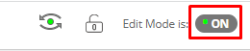 | 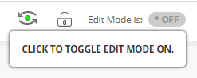 | 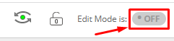
The date management tool allows you to easily adjust all content and tool dates in your course. You can choose to adjust dates automatically or individually from one convenient location.

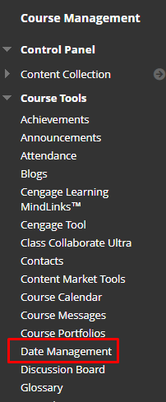
All items with dates are supported in Date Management.
Including:
- Content (items, files, audio, etc.)
- Assessments (tests, surveys, assignments, etc.)
- Tools (discussions, blogs, journals, announcements, etc.)
- Manual grade columns
- Course and Organization tasks
The task due dates are moved during the bulk move process, and they do not appear in the Review and Edit Dates screen. Date Management does NOT support editing of due dates for tasks from review and edit dates screen.
Publisher content is shown on the Date Management Review page. You cannot adjust the dates of publisher content from Date Management.

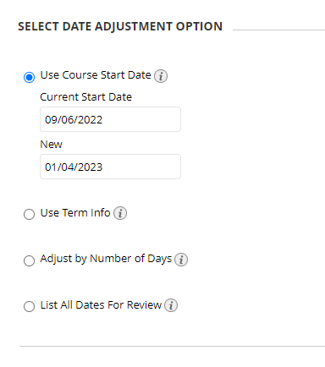
- Use Course Start Date
Use this option when adjusting for new terms. Adjust dates according to the course start date.
In the above example the original course start date was September 6. 2022 and the new course date is January 4, 2023.

- Adjust by Number of Days
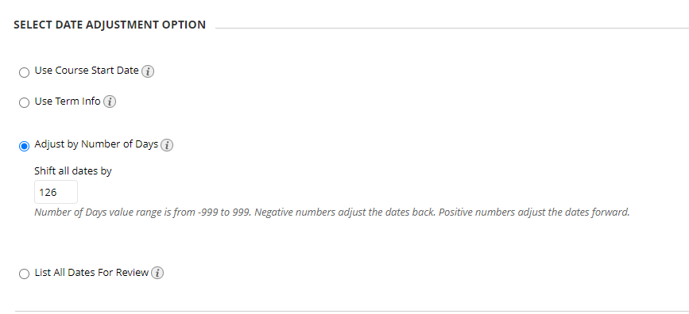
Use this option when you know exactly how many days you want to adjust dates by. Type the number of days you want to adjust all dates in the course by. This is based on the dates that are currently set for each item in the course, not today’s date.
If on June 1 you adjust dates by 30 days, the assignment that was set for September 1 is now due October 1. Negative numbers move the dates back, positive numbers move the dates forward.
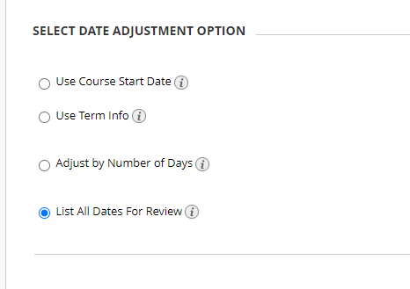
- List All Dates for Review
Use this when you want to review dates before adjusting them. Select this option to display a list of all content and tools with dates in the course on the Date Management Review Page. Use this option to review all of the dates and analyze them for adjustment.

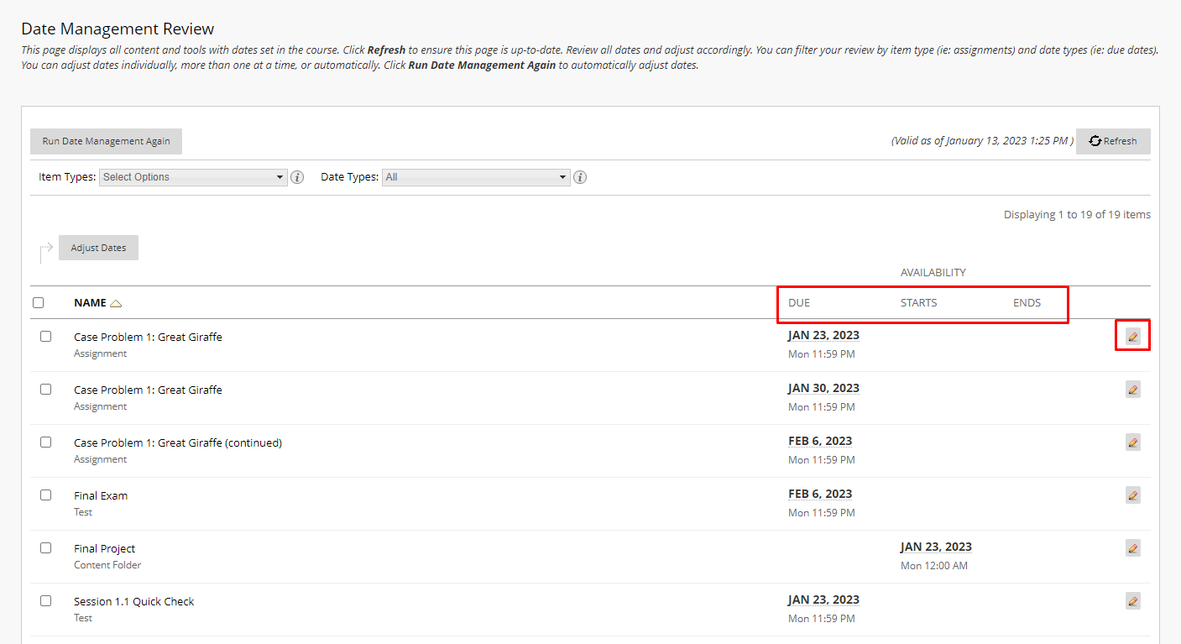
- After choosing how you want to adjust the dates press submit. The Date Management list will come up and you can compare your dates to ensure they are correct.

Interested in more educational tools? Check out our How-To Guides at: www.ufv.ca/myclass/faculty-centre/faculty-tutorials or email us at asktlc@ufv.ca

