Export, Archive and Import a course
Make sure edit mode is on
(Top right of screen)
Edit Mode is ON | Click to toggle. | Edit Mode is Off
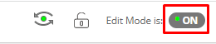  Export | 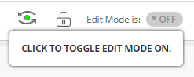 | 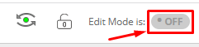
Exporting, archiving and importing a course lets you save the course for later. Exporting: the process of saving a complete copy of your course content only, does not include user records.
Archiving: the process of saving a complete copy of your course and user interactions such as discussion.
Importing: the process of creating a new course with an old courses export or archive.

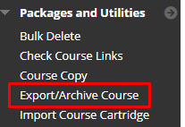
- On the left menu click Packages and Utilities and then Export/Archive Course
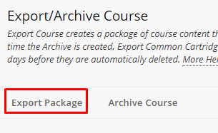
- Click Export Package
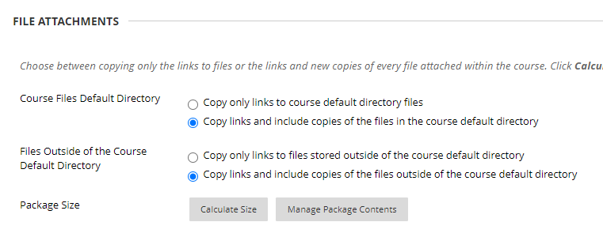
- Choose “Copy links and include copies of the files in the course default directory” and “Copy links and include files outside of the course default directory”
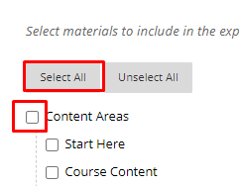
- Choose the content you wish to export.
- Click Submit
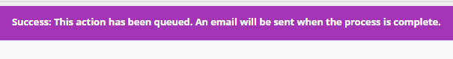
- A success message will appear at the top.
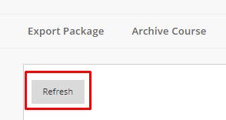
- Click Refresh
- Keep clicking refresh until the “Date Created” time stops increasing. Larger courses will take longer to export so this time will change as the file is being saved.
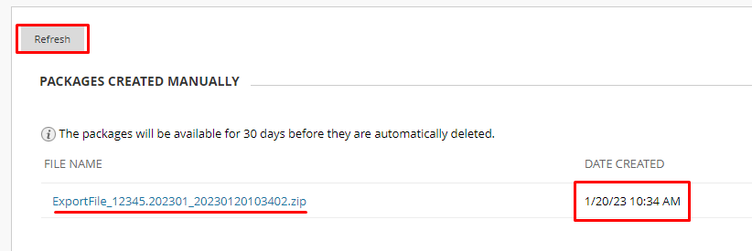
- Click on the name of the export file. It will download to your downloads folder.
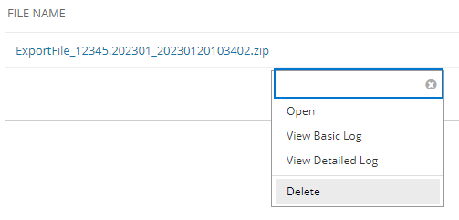
- After downloading delete the export file.

Archive
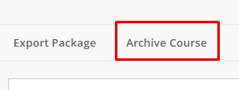
- Click Archive Course
- Choose if you want the Grade Center History.
- Choose “Copy links and include copies of the files in the course default directory” and “Copy links and include files outside of the course default directory”
- Click Submit.
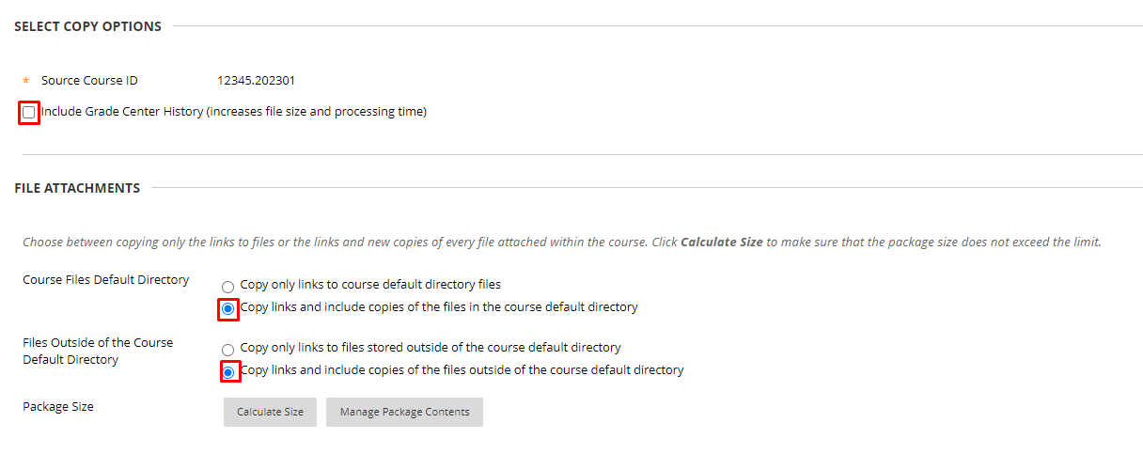
- A success message will appear at the top.
- Click Refresh

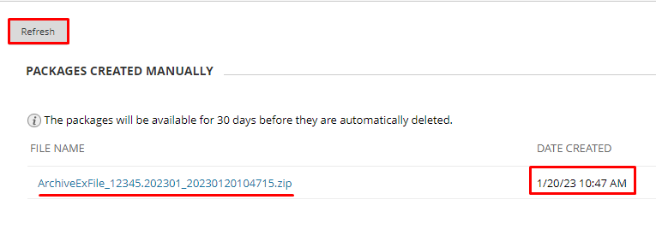
- Keep clicking refresh until the “Date Created” time stops increasing. Larger courses will take longer to archive so this time will change as the file is being saved.
- Click on the name of the archive file. It will download to your downloads folder.
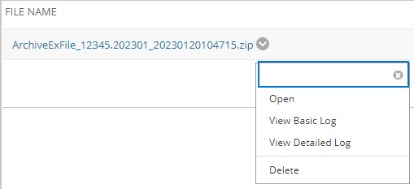
- After downloading delete the archive file.

Import
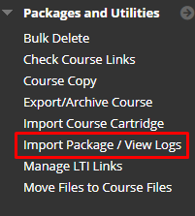
- On the left menu choose Import Package/View Logs
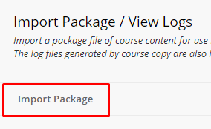
- Click Import Package
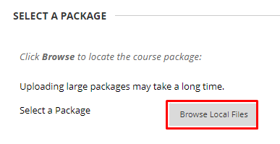
- Click Browse Local Files
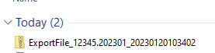
- Choose the Export or Archive file.

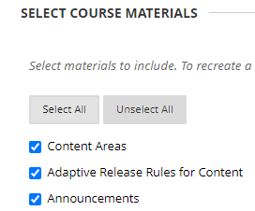
- Select the content you want to import.
- Click Submit.
- A success message will appear at the top.

Interested in more educational tools? Check out our How-To Guides at: www.ufv.ca/myclass/faculty-centre/faculty-tutorials or email us at asktlc@ufv.ca

