Grading Using a Rubric
Make sure edit mode is on
(Top right of screen)
Edit Mode is ON | Click to toggle. | Edit Mode is Off
 | 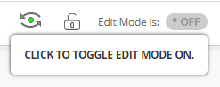 | 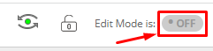
You can create a rubric in the grade center without having an assignment submission.

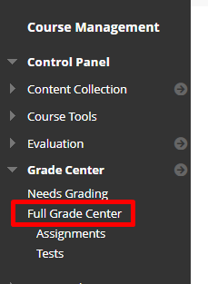
- Go to the full grade center.
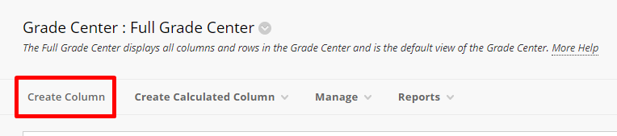
- Click create column.
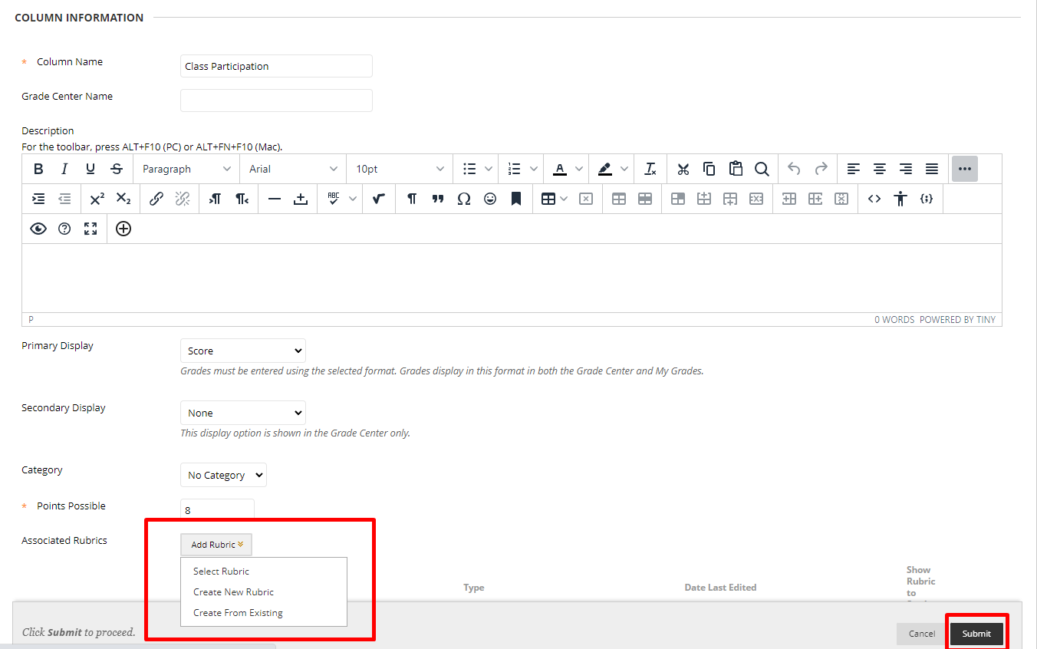
- Create a new Rubric.
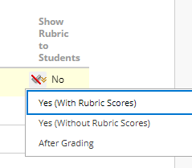
- Ensure that the rubric is showing to students
- Submit and go to the created column. Choose a student and click the arrow next to the column and choose View Grade Details.
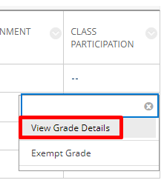

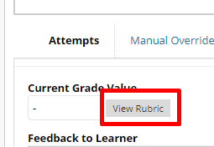
- Select View Rubric next to the Current Grade Value.
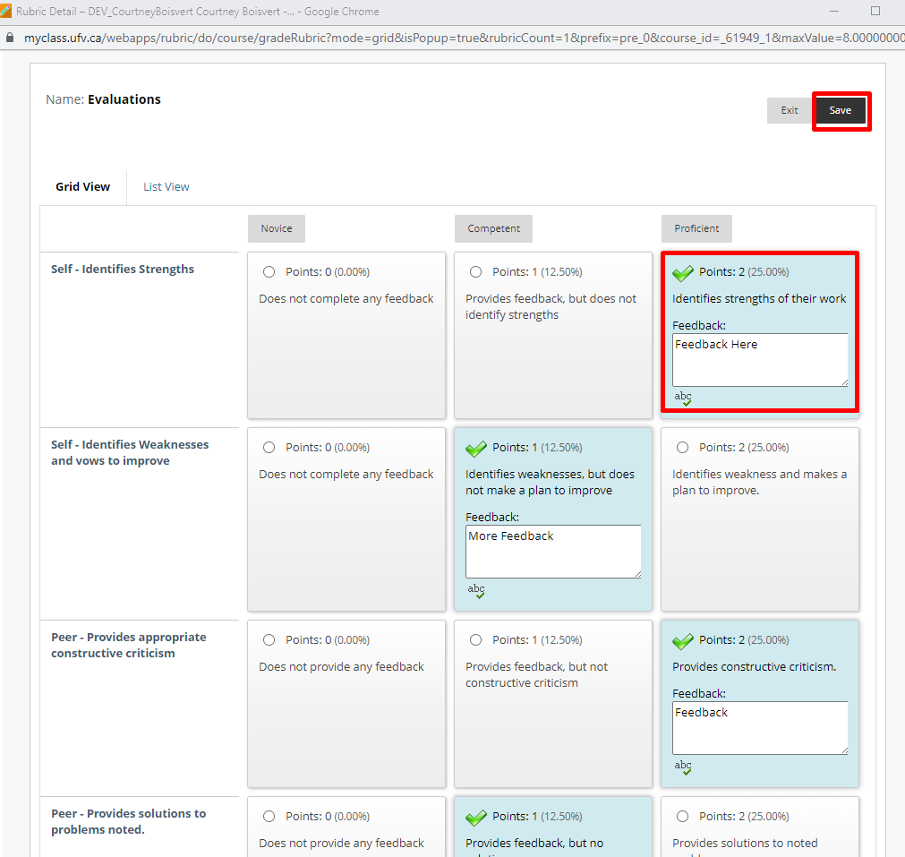
- Fill in the feedback
- Press Save.

Student View.
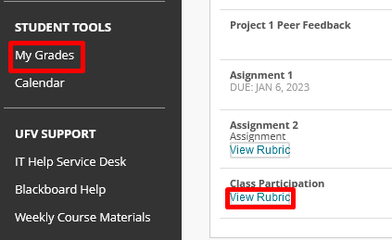
- Students can view their rubric in MyGrades.
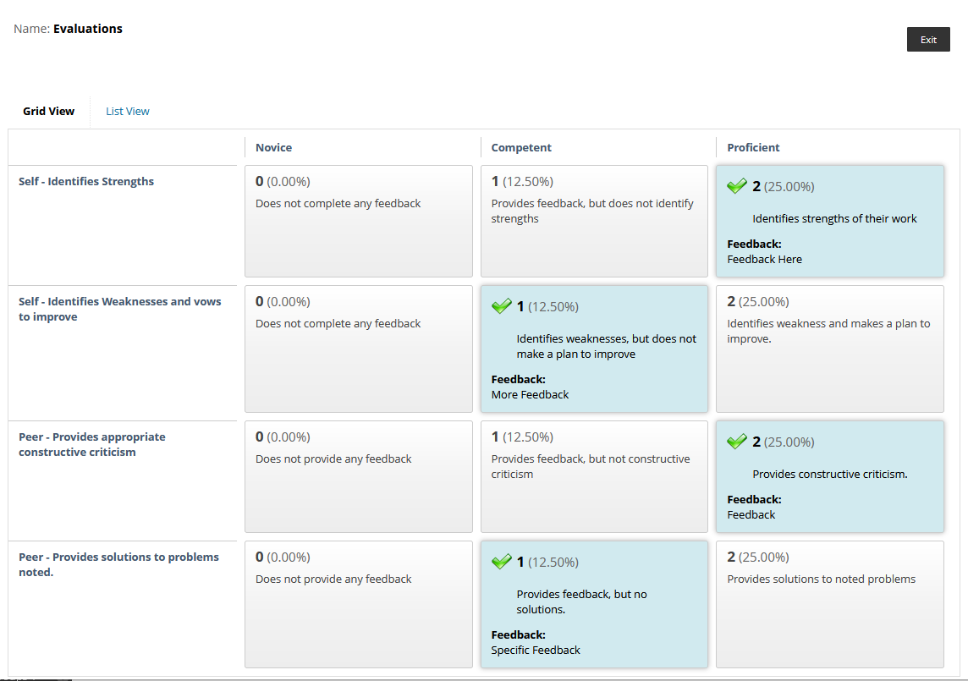
- Students will then see the rubric.

Interested in more educational tools? Check out our How-To Guides at: www.ufv.ca/myclass/faculty-centre/faculty-tutorials or email us at asktlc@ufv.ca

