Manually Override Grades
If you need to input a grade when a student has not completed an assignment you can manually override the grade. If you do this before you finalize your grades you may have a student hand in a late assignment and you will only see the override grade of 0.

Possible Scenario
- A student did not submit their assignment before the assignment due date.
- The instructor manually provided the student a 0.
- The student submits the assignment late.
- The instructor grades the submitted assignment and provides a grade.
- The grade center still shows 0.
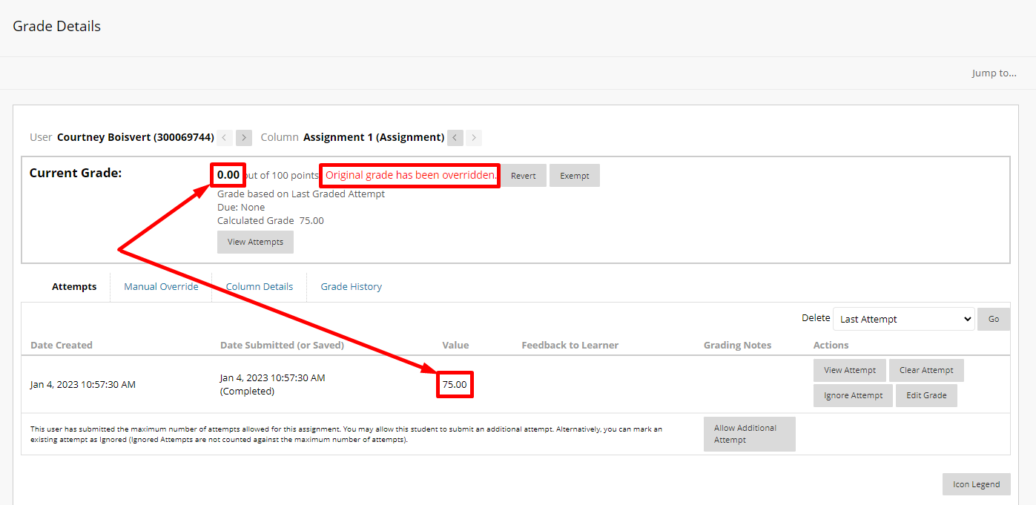
- This is because an override grade takes precedence over all grade entries.
To prevent this:
- Revert the manually overridden grade.
  - Click the arrow next to the grade and choose view grade details.
  - Click revert grade next to the overridden grade.
Best Practice:
Do not manually override grades until you are no longer accepting assignments.

Interested in more educational tools? Check out our How-To Guides at: www.ufv.ca/myclass/faculty-centre/faculty-tutorials or email us at asktlc@ufv.ca

