How to Revise Submitted Grades
Make sure edit mode is on
(Top right of screen)
Edit Mode is ON | Click to toggle. | Edit Mode is Off
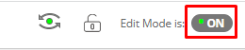 | 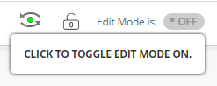 | 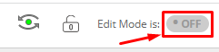
This allows you to revise a grade once it has already been submitted.

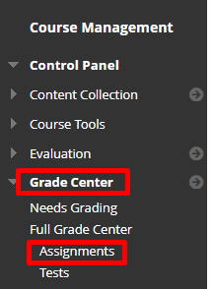
- Click Grade Center and Click Assignments
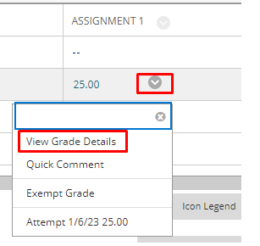
- Click the arrow to the right of the grade you need to revise and click View Grade Details.

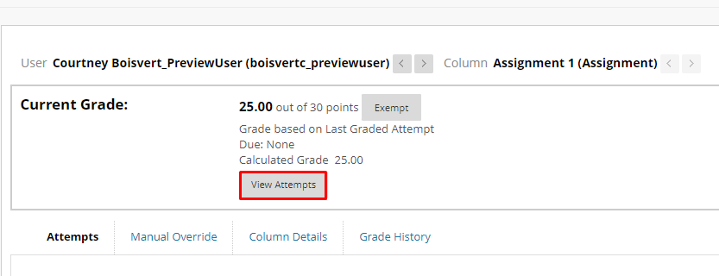
- Click View Attempts

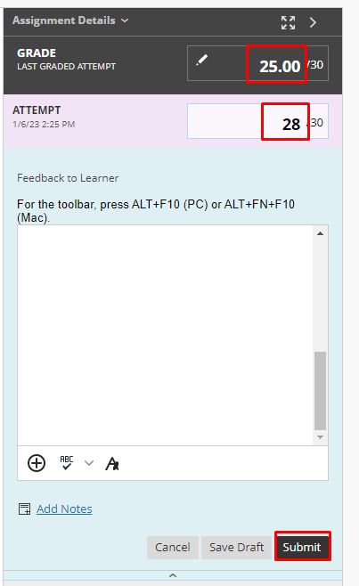
- Open the grading panel and revise the grade as needed and click Submit.

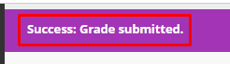
- You will be reverted back to the grade details and you will see a confirmation.

Interested in more educational tools? Check out our How-To Guides at: www.ufv.ca/myclass/faculty-centre/faculty-tutorials or email us at asktlc@ufv.ca

