Zoom - How to Make a Main Meeting Room for the Whole Semester

Email: askTLC@ufv.ca Video: video.ufv.ca

1] (myClass course’s left menu) Zoom Classroom

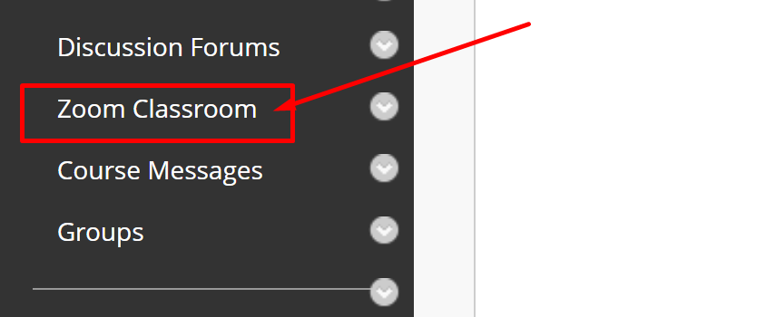

2] (top right) Schedule a New Meeting

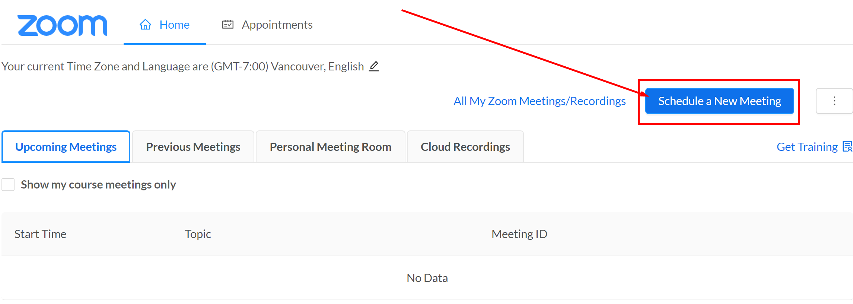

3] Topic > Recurring Meeting > No Fixed Time

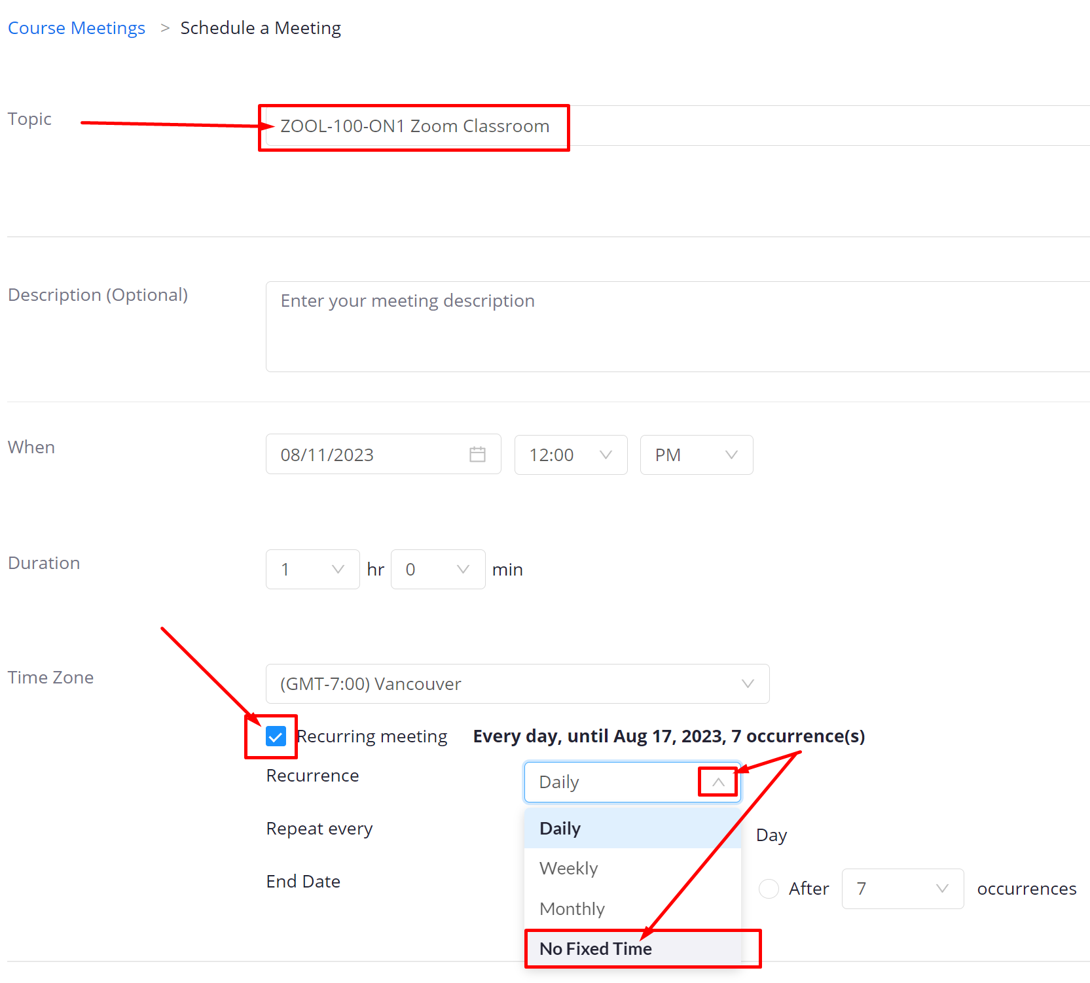

4] (below) Enable join before host
> Mute participants upon entry > Save

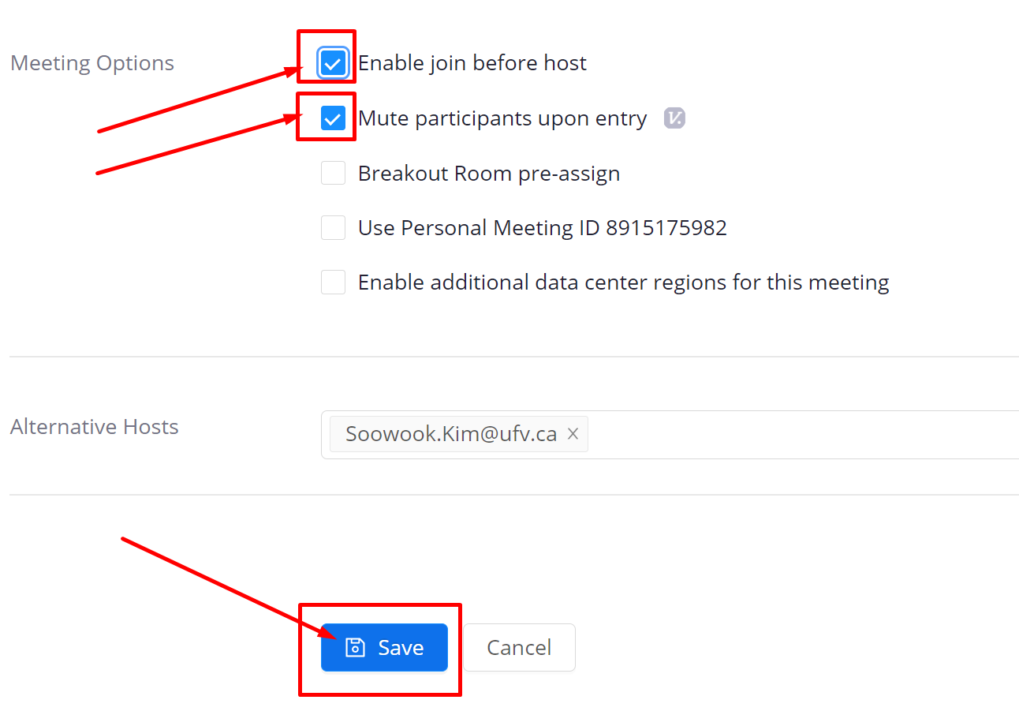

5] (top left) Home or Course Meetings

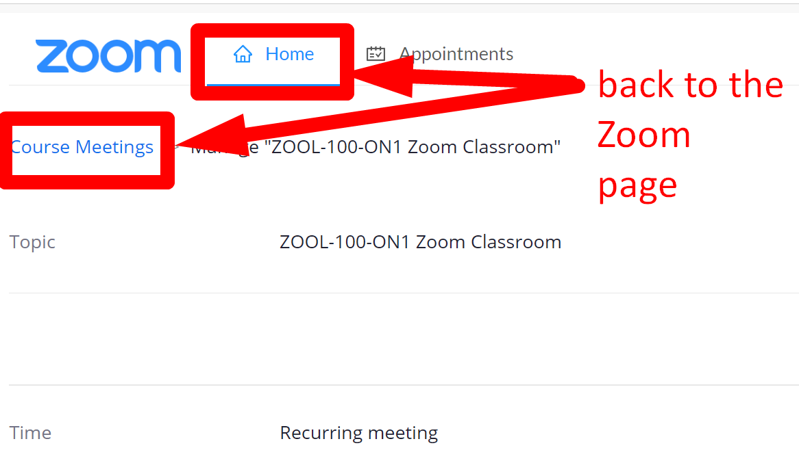

6] You can edit options or start the meeting.

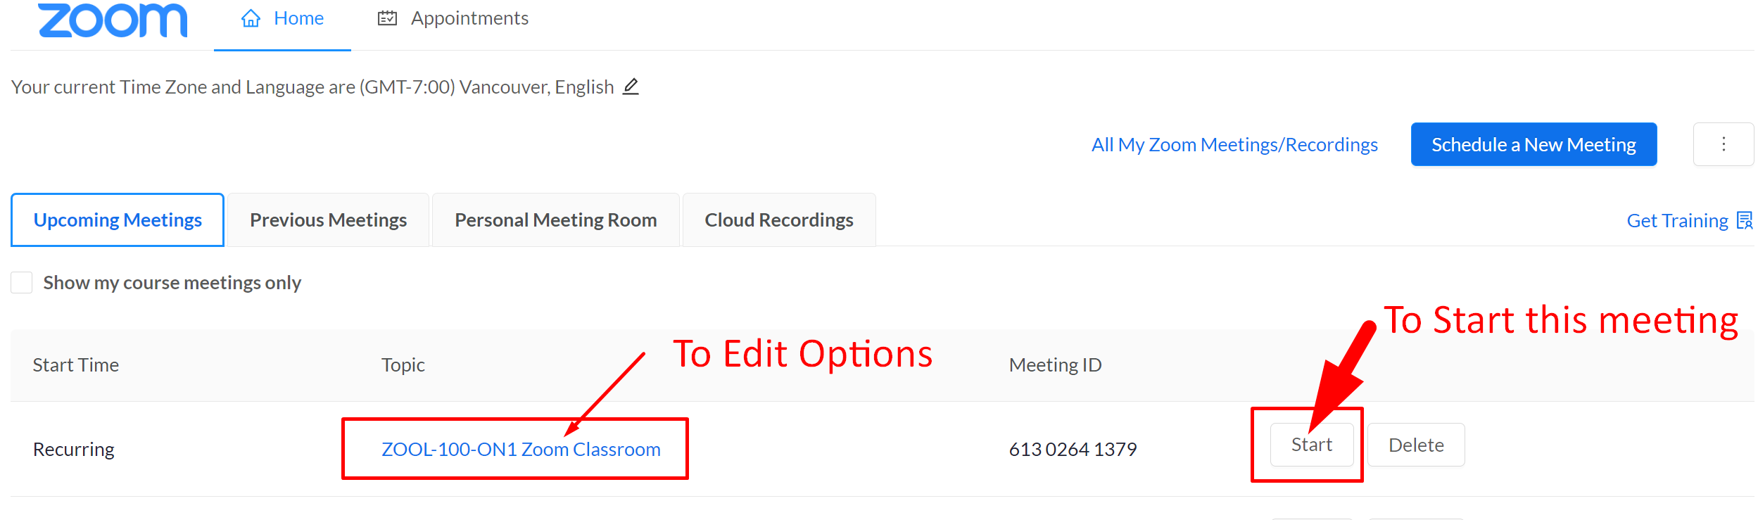

Revised by Soowook Kim on AUG 11, 2023.

