Policy 46: Instructional Responsibilities

FAQ Guide
Created by Claire Hay, Learning Specialist, on behalf of the P46 Working Group
This FAQ guide is designed to support faculty in implementing the revised Policy 46: Instructional Responsibilities, which came into effect on 1st January 2026. For questions about policy implementation, please contact your Associate Dean.
It is recognized that it will take time to fully roll out and socialize the policy through an intentional, steady, and supported approach. This policy is descriptive, not prescriptive, and largely reflects what most faculty are already doing. The revised policy provides guidance where needed.

Policy Statements
- Who informs me of Policy 46 (and other policies)?
Your Department Head/Director is the individual who directs you to the relevant policies that connect to your teaching as soon as you are hired. If you have not received this information, ask.
- Where do I find the Collective Agreement?
You can find the current Collective Agreement here.
- Do I have to create a course syllabus for each course that I teach, even if I am teaching multiple sections of the same course?
Yes, each course (and section) requires its own course syllabus.
- Does my course syllabus need to be approved?
This depends on your department/faculty. Your Department Head/Director will provide guidance. Departments are required to keep copies of all course syllabi.
- Why does my course syllabus (and other materials) need to be accessible? Where can I get help with this?
Accessible BC Legislation requires post-secondary institutions to support all students. When we teach, all materials are to be made accessible. These video resources may help you create accessible materials.
- What is Universal Design for Learning? How can I get support with this?
Universal Design for Learning is a framework for supporting all students. It has 3 components: Multiple Means of Engagement, Multiple Means of Representation, and Multiple Means of Action and Expression. Generally, think about how you can present materials in multiple ways, have students demonstrate learning in different ways, and build learning skills.
- How will I know if students in my courses have CAS accommodation? Do I need to ensure that they are met?
You will receive an email from the Centre for Accessibility Services for each student in your course who has formal accommodation. You will be asked to sign this letter. At the start of the semester, the student will reach out to discuss specific accommodations. You will not be informed of the reasons for accommodation unless the student chooses to self-disclose. Ensure that accommodations are met, unless a student waives them in writing.
- Can I change the dates/times or mode of my courses after the UFV Timetable is published?
The UFV Timetable is developed to schedule courses in required delivery modes and to cover all available time blocks and available rooms. Some blended courses meet face-to-face every 2 weeks, with other courses using the same room in alternate weeks. Switching when you meet face-to-face impacts students and instructors alike. Please follow the UFV Timetable. In extenuating circumstances (e.g., illness), changes need Department Head/Dean approval.

Communicating Course Expectations
- When does my syllabus need to be provided to students?
Your syllabus is to be available to students on the first day of the semester. The syllabus is provided to students via UFV email or posted on the LMS. The LMS opens to students on the first day of the semester, and students will be looking for course information at that time.
- Does UFV use a formal syllabus template
No. Instead, we use a list of required syllabus components. Your department may provide a template, or you can create your own design. It is important that the syllabus contains all required information.
- Can I make changes to my syllabus after the start of class?
Yes, but sometimes approval from the Department Head/Director is required. This chart shows some examples of changes that an instructor can make and those requiring approval. If you are not sure, ask your Department Head/Director.
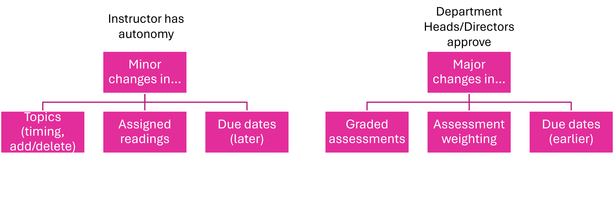

Course Scheduling Information
- Can I require students to attend out-of-class activities?
These activities are to be noted in the UFV Timetable and dates provided to students on department websites no later than one month prior to the start of classes (as set out in Attendance policy 62). The official course outline also indicates that these activities may occur.
- A student notified me in advance that they would be missing class. What are my responsibilities?
You could meet with the student and discuss how they may review the missed material. You could suggest additional resources, provide your notes, or ask them to connect with someone in the class. You do not need to reteach the material that was missed, and you are not required to keep attendance and directly reach out to missing students (only those who contact you directly).
- If I am planning to be away for a conference during the semester, what do I need to do?
Professional development activities like conferences need to be pre-approved by the Dean. When approved, inform your students and provide materials on the LMS or via email for them to complete before you leave.
- If I get sick or have other extenuating circumstances and need to miss a class, what do I do?
Inform your Department Head/Director of your absence and inform students via email and LMS as soon as possible. If, and when you are able, provide materials to students.

Meeting and Communicating with Students
- I am teaching an asynchronous course; do I need to schedule student office hours?
Yes, you are responsible for being available for students for 1 hour per week (even those that are asynchronous). These times are listed in the course syllabus.
- I am teaching multiple courses this semester. Do I need to offer student office hours for each course?
No. You are responsible for holding 1 hour per week of student office hours. These hours are pre-determined and listed in the syllabus.
- Do I need to hold student office hours in multiple formats?
It is preferable for you to be available for student office hours in the same mode as your course. But we encourage you to be available in multiple formats. For example, during your student office hours, be available in-person and online in an open Zoom room.

Assessment and Evaluation
- I would like to include attendance and/or participation in my evaluation. What do I need to consider?
If course learning outcomes include attendance and/or participation requirements, then these may be assessed. If these are not explicitly noted, consider how these activities align with outcomes. If you decide to use attendance and/or participation, clearly explain to students how and why this is in place and consider ways to make these assessment activities inclusive for all students.
- I am teaching online (synchronous or asynchronous delivery), and I want to hold in-person exams. Can I do this?
Yes, you can offer in-person exams. This request is to be approved by the Dean in advance and noted in the UFV Timetable.
- A student missed an assessment deadline or exam for extenuating circumstances; can I ask for a medical note or other documentation?
Here is a suggested syllabus statement: “If you miss an assessment due to extenuating circumstances (e.g., serious illness, emergency, bereavement), contact me within 48 hours to discuss options. I may request documentation where appropriate, particularly when a rescheduled exam is arranged through Assessment Services (which requires documentation). For disability-related needs, please connect with CAS; I will implement approved accommodations.”
- How long do I have to return students’ work to them?
Timely return of assignments is important for students so they can gain insights from feedback on their strengths, areas for improvement, and other information, including grades. Students should have received sufficient feedback by the course withdrawal date to gauge their likelihood of success. When designing assessment activities, consider your scheduling between courses and how you will provide timely feedback.
- What does facilitate approved CAS accommodation mean for assessment and evaluation?
You will be notified by the Centre for Accessibility Services of any approved accommodation for students in your course. We have a duty to accommodate. You will be informed of the type of accommodation required, and you are responsible for working with CAS and the students to meet accommodations.
- Are there any days when I cannot have students submit assessments or write exams?
Due dates cannot be set for Fall and Winter Reading Breaks and the days between the end of classes and the start of formal exam periods. In addition, students may ask for a deferral of due dates and exams if they fall on a religious/holy day as specified by the Office of the Registrar and requested 1 week in advance with no penalty.
- Can I schedule assessment activities on the last instructional day of the semester?
It depends. If an exam/quiz is worth more than 20%, then it is scheduled during the formal exam period. Other activities, such as presentations and lab exams, can be scheduled for the last instructional day of the semester.
- Can I ask students to use non-UFV-approved tools for assessment activities?
If the tools are FIPPA compliant and students do not have to create an account where personal information is shared, then they may be used. Alternative arrangements must exist for students who do not wish to use these tools.
- Can I use AI tools to review student work?
Tools not approved by UFV may not be used to review student work. Any work that is reviewed is to be anonymized.

Use of Technology for Teaching and Learning
- Can I use AI to create course materials?
Yes, if you disclose this to your students in the appropriate documentation.
- Do I need to tell students I am using Turnitin and other online tools in advance?
Yes. Please indicate in the syllabus and in assessment documentation.

